**QA Challenge**

**Introduction**:

Based on the QA challenge provided by Ceri Pritchard. I have successfully written a program in Java using Eclipse IDE and SQLite(database) for Widget Ltd company to produce a number of reports based around Departments and Employees. This is stored in GIT repository

**https://github.com/sareen-ankita/widget.git**

**Main features:**

Database file Creation in SQL lite tool where data records for Employees and Department are added for Widget company.

The database file and tables will be created by program.

Database file structure created from the code is as follows:

* Records. dB (Main database file)
  + Departments (Table1)
  + Employees (Table 2)

Records will be added to tables

User can fetch records based on the following requirements.

**Employees in Department**

For a specified Department Id, output the following columns:

● Employee Id

● Employee Name

● Job Title

● Salary

**Employees in Location**

For a specified Location, output the following columns:

● Employee Id

● Employee Name

● Job Title

● Salary

● Department Name

User can extract report for Employees in department List.

Records will be deleted once the operation is complete as requested for GDPR.

**Pre requisites -**

* Eclipse Editor
* SQLite Database:

(Instructions to download is quite clear in the link below)

<https://www.sqlitetutorial.net/download-install-sqlite/>

<https://www.sqlite.org/download.html>

Please Download the SQLite binaries depending on windows (32–64-bit OS).

* Java (JDK1.8 version)
* Permission Access to the C: and D: drive in your local machine – to create table folders and check extract outputs (in case if any of them is not available you may have to amend the path in code)
* Access to Git hub repository: <https://github.com/sareen-ankita/widget.git>

**Understanding Requirements and Explanation of Working**

The project requirement was to create records in 2 tables for Employees and Database and user should be able to report on them based on the following criteria:

**Employees in Department**

For a specified Department Id, output the following columns:

● Employee Id

● Employee Name

● Job Title

● Salary

**Employees in Location**

For a specified Location, output the following columns:

● Employee Id

● Employee Name

● Job Title

● Salary

● Department Name

Due to GDPR requirements data should not be held in any database once the user has viewed and extracted the data.

The code successfully run and creates the Database in C:\sqlite\db\records.db--> Name of the Main database file

Creates 2 tables called – Employees and Departments.

These will be created automatically by the program once the software is installed and code is executed successfully.

This can be seen in SQLITE GUI or in the above folder structure

Department Data structure and Data sets

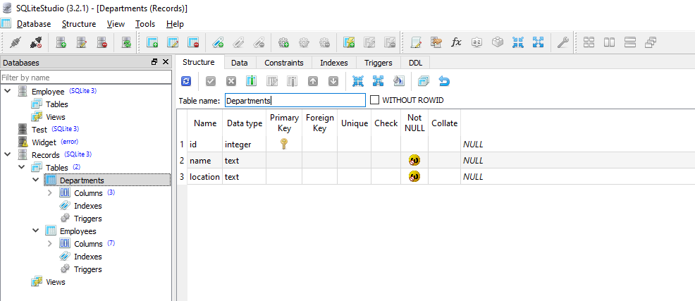

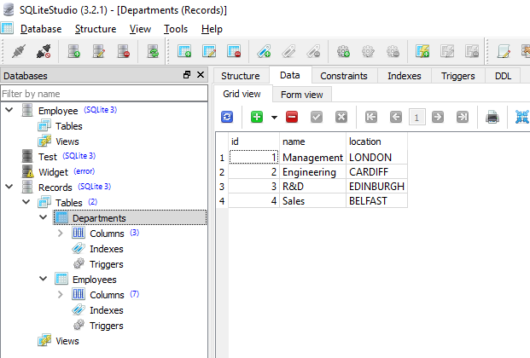

Employees Data structure and Data sets

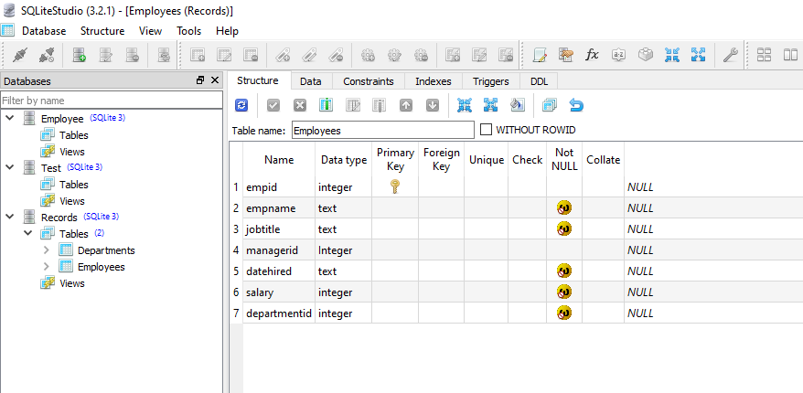 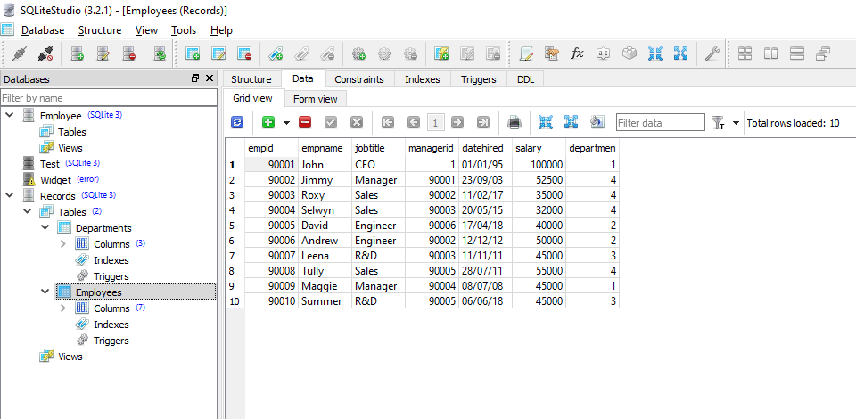

The program at execution will ask for input from user to enter location and Department id to fetch records and generate reports based on user’s input on the program console.

The program will also show the choices to select the user’s input.

Once user chooses the input the records will be fetched and user will be asked again if they need report.

If they select ‘Y’ - yes then extract output.csv will be created

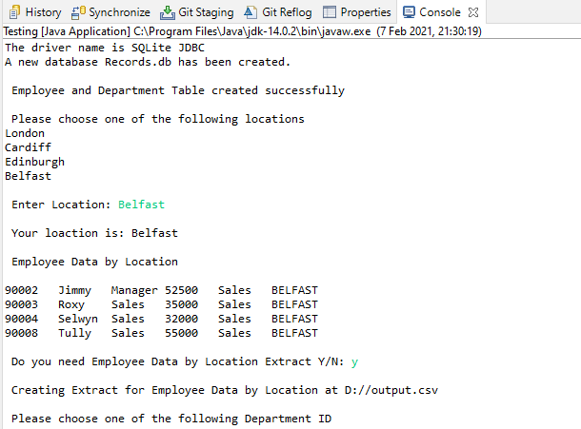

Output.csv created

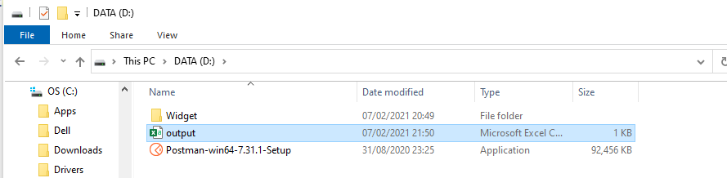Records in output.csv

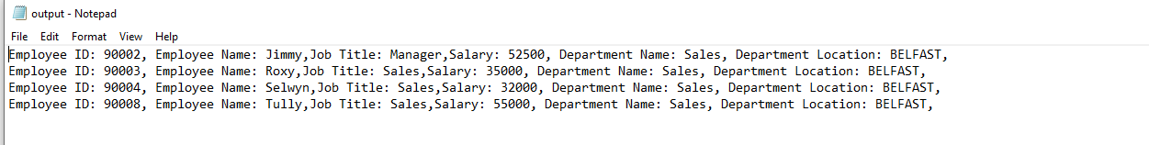

User will then be asked to enter Department id (allowed values 1-4)

Department

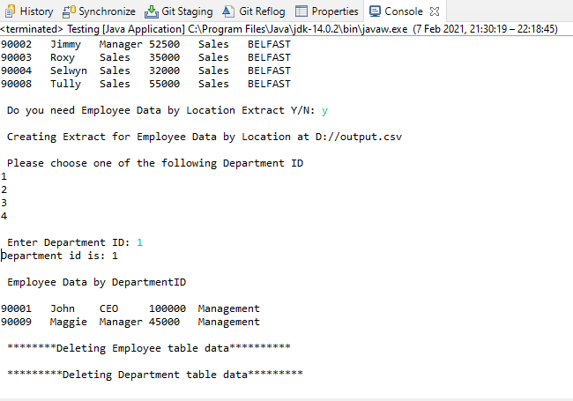

Please note: I have not created any CSV extract functionality for Department ID query.

After the successful execution, all records will be deleted.

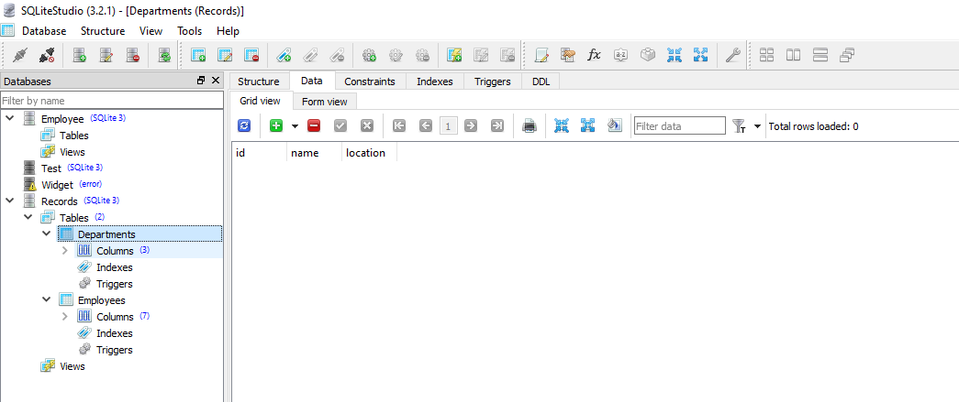

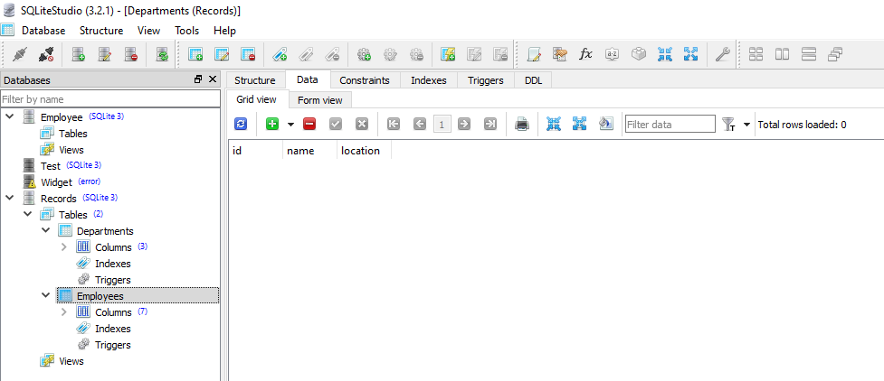

This completes the working and execution of the program.

Test scenarios that are considered while creating and executing the code are as follows.

1. Check whether database file and tables are created successfully.
2. Check whether data is inserted into tables correctly.
3. Check user is able to select the location and department id from the command prompt with the correct input.
4. Check if user enters invalid values for location and department id then user should get error message – cannot retrieve the records – records does not exist in the system and no records should be fetched.
5. Check user is able to extract report on Employee by location query and is in .CSV format
6. Check if user selects not to extract report then Output file should not be created or override with new set of data if Output file already exist.
7. Check records are deleted from tables and tables are empty once the operation is complete.
8. Check if we repeat the steps again new records are created and all functionality works as expected.

Test Outcomes: All the above scenarios have been considered while developing the code.